Pearl Ayem

34404160

**Lab 4 ATSC 303**

**Calculations for static calibration of Type E thermocouple**

1,2 and 3:

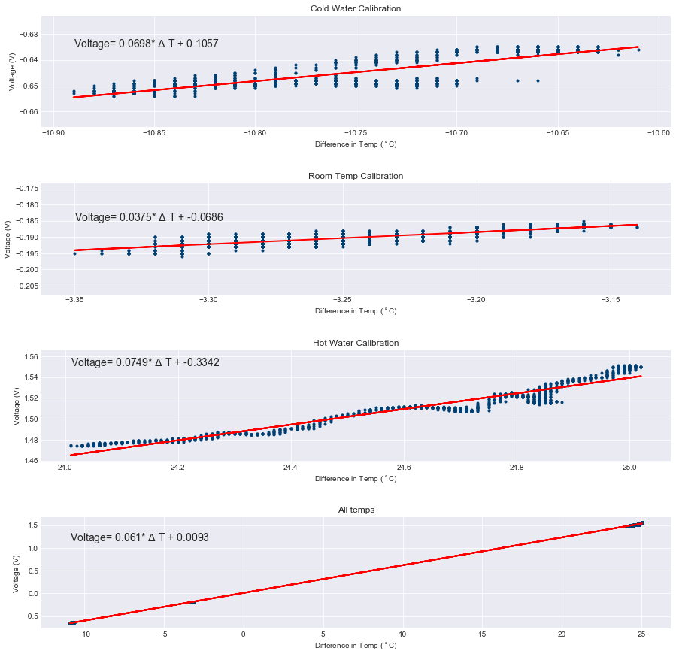

4. The coefficient values represent the slope(m) and y-intercept(b) of the best fit line.

The plots generated gave the following coefficients:

Cold Water Calibration

c0 = -1.5135

c1 = 14.325

Transfer Eq: Voltage= 0.0698* ΔT + 0.106

Room Temp Calibration

c0 = 1.8318

c1 = 26.701

Transfer Eq: Voltage= 0.0375* ΔT + -0.069

Hot Water Calibration

c0 = 4.4595

c1 = 13.343

Transfer Eq: Voltage= 0.0749* ΔT + -0.334

All temps

c0 = -0.1531

c1 = 16.401

Transfer Eq: Voltage= 0.061* ΔT + 0.0093

The transfer equation equation generated using these coefficients, was used to find a predicted value for the output voltage and is compared in the table below with the NIST Standards value.

According to the table this is the values for output voltage:

|  |  |  |
| --- | --- | --- |
| ΔT | Predicted Voltage out | NIST value |
| -11 | -0.6622 | -0.639 |
| -3.35 | -0.181 | -0.176 |
| 25 | 1.5394 | 1.495 |

Therefore these compare to each other closely, although not perfectly.

5. What temperature range is this equation valid for and why?

The plots generated gave the following coefficients:

Cold Water Calibration: ΔT = 14.325* Voltage + -1.5135

Room Temp Calibration: ΔT = 26.701* Voltage + 1.8318

Hot Water Calibration: ΔT = 13.343* Voltage + 4.4595

All Temps: ΔT = 16.401* Voltage + -0.1531

6. We have not used perfect calibration methods such as using ice baths or boiling water. Additionally, the sensors that were exposed to air still felt effects of their surrounding and their temperature was not entirely constant. Over the time span, the water temperatures also changed. We assumed that the response was step response too. I would used more regulated water temperatures to improve the experiment, in order to increase precision.

**Calculations for dynamic performance of the thermocouples**

indicating the areas on the graph that represent the dynamic response to each step input

1. 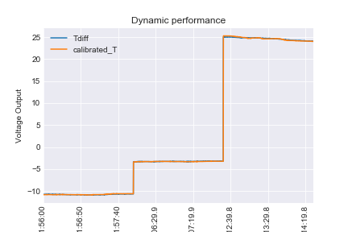
2. ?????
3. Two different thermocouples would have different densities, surface areas and heat resistance, and therefore different τ values
4. ????
5. ??????
6. ???

**Further lab questions (based on lectures and readings)**

$τ= \frac{\left(T_{s}-T_{air}\right)}{\frac{dT_{s}}{dt}}$ $τ= \frac{\left(T1-T_{air}\right)}{\frac{T1-T_{0}}{t_{1}-t_{0}}}$

2. Assume: The system is linear and that the contributions of the 2 different frequencies are independent.
$$T_{filtered}= A_{1}R_{1}\sin\left(\frac{2πt}{P1}\right)+ A_{2}R_{2}\sin\left(\frac{2πt}{P2}\right) \\ 3\sin\left(2t\right)+5\sin\left(7t\right)= A_{1}R_{1}\sin\left(\frac{2πt}{P1}\right)+ A_{2}R_{2}\sin\left(\frac{2πt}{P2}\right) \\ A_{1}= 3 \\ A_{2}= 5 \\ \left(\frac{2π}{P1}\right)=2 →P1= π →f_{1}= \frac{1}{π} \\ \left(\frac{2πt}{P2}\right)=7 →P2= \frac{2π}{7} →f_{2}= \frac{7}{2π} \\ R=\frac{1}{\sqrt{1+4π^{2}f^{2}τ^{2} }} \\ R_{1}=\frac{1}{\sqrt{1+4π^{2}{f_{1}}^{2}τ^{2} }}=\frac{1}{\sqrt{1+4π^{2}{\frac{1}{π}}^{2}τ^{2} }}=\frac{1}{\sqrt{1+4π τ^{2} }} \\ R_{2}=\frac{1}{\sqrt{1+4π^{2}{f_{2}}^{2}τ^{2} }}=\frac{1}{\sqrt{1+4π^{2}{\left(\frac{7}{2π}\right)}^{2}τ^{2} }}=\frac{1}{\sqrt{1+49 τ^{2} }}$$

$$T_{filtered}= 3*\frac{1}{\sqrt{1+4π τ^{2} }}\sin\left(\frac{2πt}{π}\right)+ 5* \frac{1}{\sqrt{1+49 τ^{2} }} \sin\left(\frac{2πt}{\frac{2π}{7} }\right)$$

$$T_{filtered}= 3*\frac{1}{\sqrt{1+4π τ^{2} }}\sin\left(2t\right)+ 5* \frac{1}{\sqrt{1+49 τ^{2} }} \sin\left(7t\right)$$

3. Yes it could approach 0 when the input frequency and response time align so that phase lag is 180°, and the system crosses the mean sinusoidal value.
4. Dynamic error = – aτ and Dynamic lag = τ
5. 700 and 1100 hPa. After fitting a straight-line equation, the transfer coefficients are ao = -7.00 V and a1 = 0.0100 V hPa-1. Average and standard deviation of the residual errors are 0.00 hPa and 0.25 hPa respectively. Evalua
   1. Bias: True Value – Mean Measured value. Since residual averages are 0, bias is 0 hPa.
   2. Imprecision: Spread of the points(range) = standard deviation of residual = 0.25 hPa
   3. Inaccuracy = 0 because it is a measure of how close the mean is to the average.
   4. Span: 3 standard deviations = 0.75 🡪 span = 0.75 hPa
   5. Sensitivity: Slope of transfer equation = 0.01 V hPa-1
   6. 3V = -7.00 V + (0.01 V hPa-1)(input) 🡪 input = 1000 hPa
6. a. 5

b. 3

c. 1

d. 2